Design your own golf stand bag
1. 1 Year Warranty
2. Wear Resistance: Made of polyester fabric, this golf shoulder bag is sturdy enough to avoid any additional wear and tear while using it. It surely guarantees you a durable lifetime for its sturdy construction and a longtime satisfactory experience.
3.5 pockets - 3 storage pockets plus a valuables pocket and insulated water bottle sleeve pocket
4. Rain Cover, Umbrella Holder loop, pencil holder, divot tool holder, Velcro Glove Holder, D ring for clip on towel and other accessories
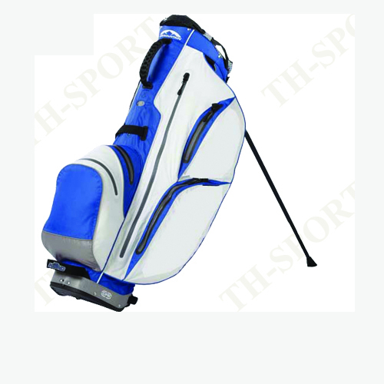
More information please click: www.tt-golf.com

